Platform FAQs

General

I can see and hear my member but they can’t see/hear me.
This is most likely a camera and microphone permissions issue.

If you are using Google Chrome:
Make sure you have granted permission for HelloSelf to access your camera and microphone for your session. You can do this by clicking on the lock icon found in the left hand corner of the address bar, shown in the image below:

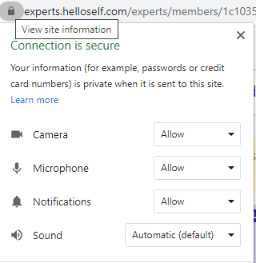

Please check that the camera and microphone are set to ‘Allow’. You may need to refresh your page after changing the settings. Please note, you need to be connecting to a session on the HelloSelf platform for this menu to appear when you click the lock icon.

If you are using Safari on your iPhone/iPad:

To have a call on iOS devices, you need to provide HelloSelf access to your webcam and microphone. By default, Safari will ask you to allow access each time you have a session. However, you can permanently allow access in your Safari settings.

If your camera and microphone are blocked, follow the steps below:
- Click on the AA icon in the top left hand corner of the screen shown in the image below:
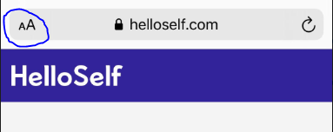

- Click ‘Website Settings’.
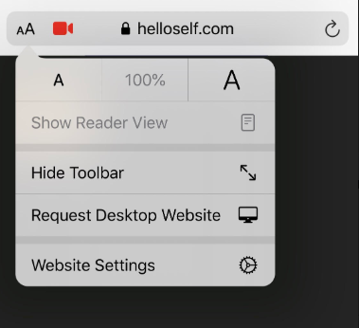

- In Settings for HelloSelf.com, click Camera and change to Allow, then do the same for Microphone.
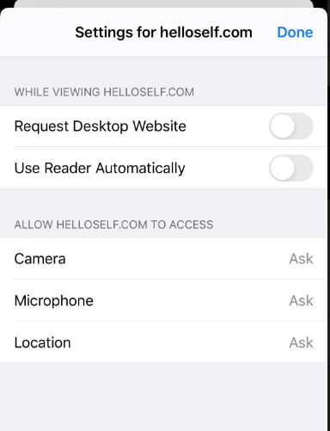
- Click on done and refresh the page. Your member should now be able to see and hear you.

My member can see and hear me but I can’t see/hear them.
- Ask your member to refresh the page.
- Refresh your page and call the member again.
- Ask your member to check they’ve allowed their camera and microphone permissions. You can send them this link for information on how to do so.

The call connection wasn’t great during my last session. How can I improve it next time?
We would advise trying the following steps to help improve the quality of your connection:
- If you are using a mobile and are on the WiFi, try switching to mobile data and vice versa.
- If using WiFi:
    - Try sitting as close to your router as possible.
    - Ensure other devices connected to your WiFi are not running data-intensive applications such as streaming movies or video calls.
- Pause any file downloads or uploads.
    - Minimising internet-hogging applications on your computer helps conserve all available bandwidth for a video session. That includes file downloads such as program updates as well as uploads – if you’re sending any large files to your office servers, now’s the time to hit pause.
- Make sure your browser is up-to-date. Running the latest version of any browser will help create a more stable experience. Generally browsers will update in the background. To check, or manually update Chrome, you can follow these instructions.
- Restart your browser: If you have not closed your browser in a while, it's useful to restart it. Also, try not to have a lot of tabs open during a session, that can slow down your computer.
- Try Incognito mode: This helps with a lot of troubleshooting. For example, if you have browser extensions, they might block your camera. Incognito mode, which does not load extensions, allows your session to run smoothly.
- Limit background tasks: Try to limit running tasks in other applications. For example, close YouTube and Dropbox before your session.
- Try switching your device off and on again.

What internet speed do I need for a stable video connection?
We recommend a minimum of 350kb/s download as well as 350kb/s upload to maintain a stable video connection (most broadband and 4g connections support this comfortably).

I am having difficulties connecting with my member on the HelloSelf platform, can I use a different platform?
Please always attempt to use the HelloSelf platform for sessions. We ask this because:
- The HelloSelf platform is fully secure and we cannot guarantee that of any alternative.
- It is the only way the member (and yourself) can make use of all the features they are entitled to.

How to resolve technical issues on a call:
- First, check that the member is online/checked in and on a supported device (Internet Explorer or Edge on a Windows laptop, Chrome on an iOS device and Firefox on an Android device will not work). For the time being you'll have to call them or use the chat to do this, but we're building functionality into the platform which will allow you to see this information yourself.
- Second, do the Tech Test if you haven’t already. This will ensure that your camera, microphone and internet are all working properly. Make sure the member has done this on their side too.
- Check that you have allowed your camera/microphone to be used by HelloSelf.
- If you're still having difficulties try refreshing the page by pressing command and R on a Mac or control R on a Windows machine. Again, ask the member to do this as well.
If after 5 minutes you are still not able to use the platform, please use Google Meets with your HelloSelf email address and let techsupport@helloself.com know after the session.

Member joining from mobile device:
Now that my members can join the session on their mobile through their HelloSelf app, does anything change for me?
Two things:
- Members will no longer ‘check-in’ before a session. When you start a session, their HelloSelf app will alert the member on their mobile device in the same way that they would be alerted to a phone call.
- There are some features such as creating goals during the session, which are not yet available.

What happens if someone calls the member during our session?

Members will be presented with a small notification asking them if they would like to answer the incoming call. If they choose to accept the call, the HelloSelf video call will be terminated and they will have to rejoin through the app. During the time that they are presented with this notification, the member’s camera will most likely be turned off but you will still be able to communicate with them We recommend making the member aware about potential incoming calls at the start of the session to preempt any issues, or else simply direct them to reject the incoming call if it occurs.

If the member plans to answer the call on the HelloSelf app, will they still check in before the session?

No. There is no prompt for the member to check in if they are using the app. Therefore, when it’s time for the session, please start the session as usual and their phone should start ringing.

What should I do if the call ends abruptly?
The member might have lost their network connection. Please wait a moment and try to restart the session which will prompt their phone to ring again. Please note that the member is not able to call you back. You must restart the session from your side.

What if the member has the app but doesn’t want to use their phone for the session?
The member will still receive a call if they are logged into the app on their phone. However, if they choose to use their desktop, they can simply ignore the call on their mobile device and check in via the platform as usual. There will be no change on your side.

Can I record on the mobile sessions?
You are now able to record, yes. A reminder to ask your member at the beginning of the session if they would like to record the session, and then you must be the one to click the red record button (highlighted in this screenshot).
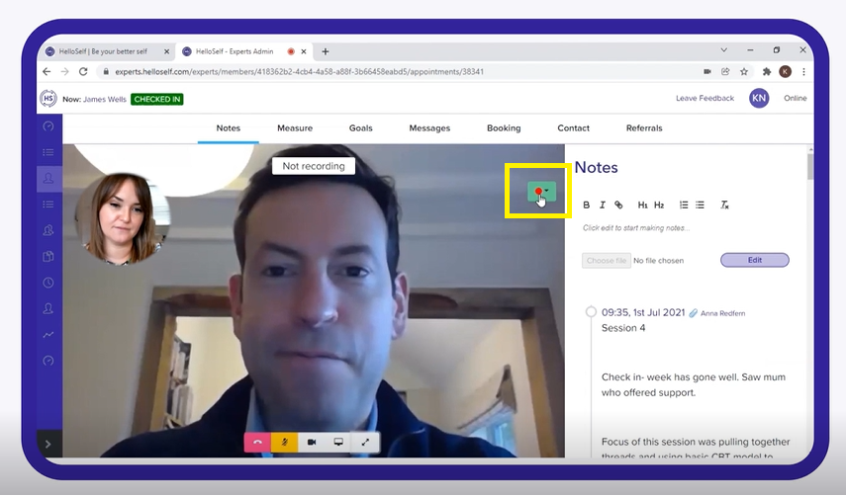

Contact Tech Support
Slack channel: tech support
Email: techsupport@helloself.com
Tel: 020 3936 8384 and ask to be put through to Tech Support.

