The Clinical Network
Slack Guidelines

Usage of Slack:
- Slack is a messaging platform which is private to HelloSelf.
- Slack is not a mandatory tool, however it is the fastest and most efficient way for us to get information to you. We want to include you in our product development, we want to hear your feedback and we want you to feel valued as part of the HS team.
- We had feedback from many of you about wanting to network and connect with your peers. In the Clinical Network Slack, you can leverage your peers, share resources and pull heads together when it comes to complex cases and professional development.
- What are the other options? You can find new announcements in the News section of your HS dashboard. We will also still be emailing to your HS inbox with new product updates, any key announcements and a regular newsletter. But for more information, to have your say on these things and to be the first to know, Slack is the place.
- Is Slack for client conversations? No, client communication is still through the HS platform where we can guarantee complete clinical safety. Slack is only to get in touch with your support at HS and your clinical professional network.

General etiquette:
- We want the Clinical Network to be a place of positivity. It goes without saying that we treat everyone with respect and kindness as in real life.
- Any specific concerns you may have with regards to your specific finances for example, please continue to get in touch via email with the HS finance team at finance-payables@helloself.com.
- Please don’t discuss cases in the main group channels, but you can reach out in a private Slack message to the CDs to arrange a time to talk, or ask in the general channel who might have experience in a certain field and jump into a private chat to discuss (please no names of members to be disclosed).

How to set up an account:

- Follow this link: https://helloselfexperts.slack.com
- Click sign in using your @helloself.com Google account
- Follow this getting started guide to set up your account and see how to get started: here
- For more information on how to use Slack’s features, follow this link
- If you would like to download the app on your phone, you can find it in the Apple App store here or for Android here. Simply login using the same HS email address and password you set up for Slack on the web.

Guide to channels:
- What are channels? Areas (see left hand menu) to bring the right people and information together in one place. Each channel will have a purpose, so the conversation will revolve around this key topic. We will share information in the channels but you can also respond to messages and share anything related to the channel topic. Please note that everyone who is a member of the channel will be able to see your message, so anything more private, please start a private chat.

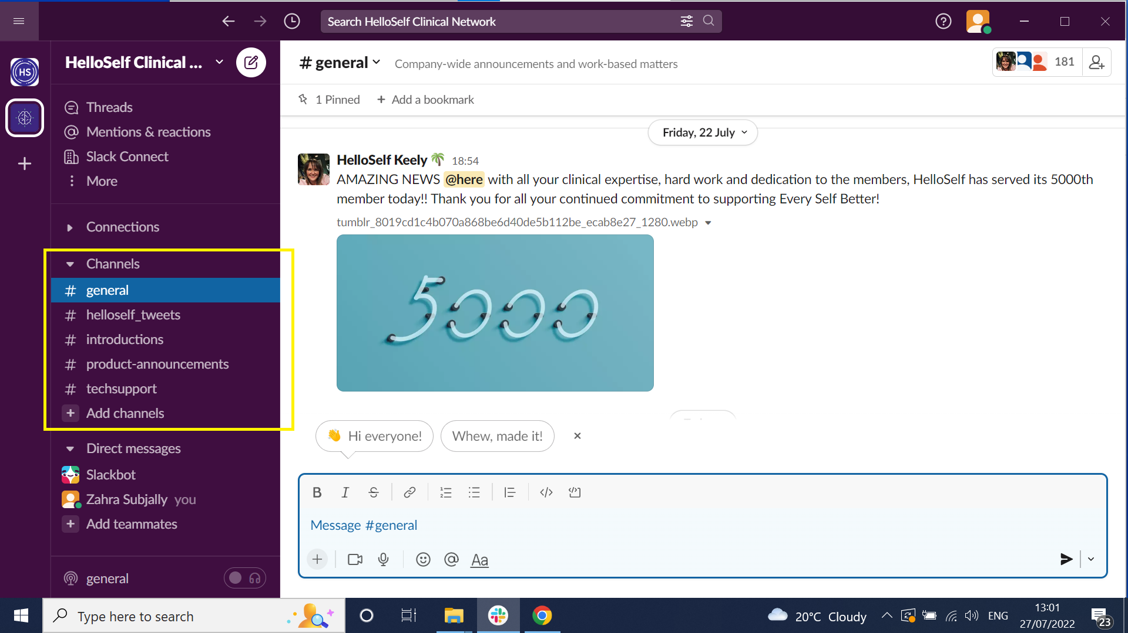

- Although we will be monitoring the channels as much as possible, please bear with us if we take a bit of time to respond, especially outside standard working hours. For urgent issues, please continue to contact the CD panel through the HS platform or get in touch with the bookings team.
- Types of channels:
  - General: this is our general channel where we’ll share any news, press or interesting announcements with you (that doesn’t concern product features). Here we’ll welcome new joiners, celebrate milestones, introduce you to different members of the community and their specialisms so that you can leverage each other’s vast experience as well as those of our CD panel.
  - Product: in this channel we will keep you updated with all our new feature launches. Whether it’s the new and improved dashboard or a new type of worksheet available, you’ll be the first to know. We’ll also use the channel to highlight some of our existing features and provide more information about how to use them to get the best outcomes for your members.
  - Tech: here you have a direct line to ask any questions around tech. Maybe you think it’s a silly question, but often other people are in the same situation. Post any questions on this channel and one of our team will come back to you. However please note that the channel is not constantly monitored outside working hours. If someone else in the community has experienced the same thing or knows the answer, feel free to respond! It’s always great to get our community helping each other. If someone posts a message in #techsupport the reply and therefore subsequent conversation will often go in a thread to avoid cluttering up the main space. Everyone can read these threads, so feel free to click into the ‘1 reply’ (see below screenshot) to read the answers to questions that have already been answered.

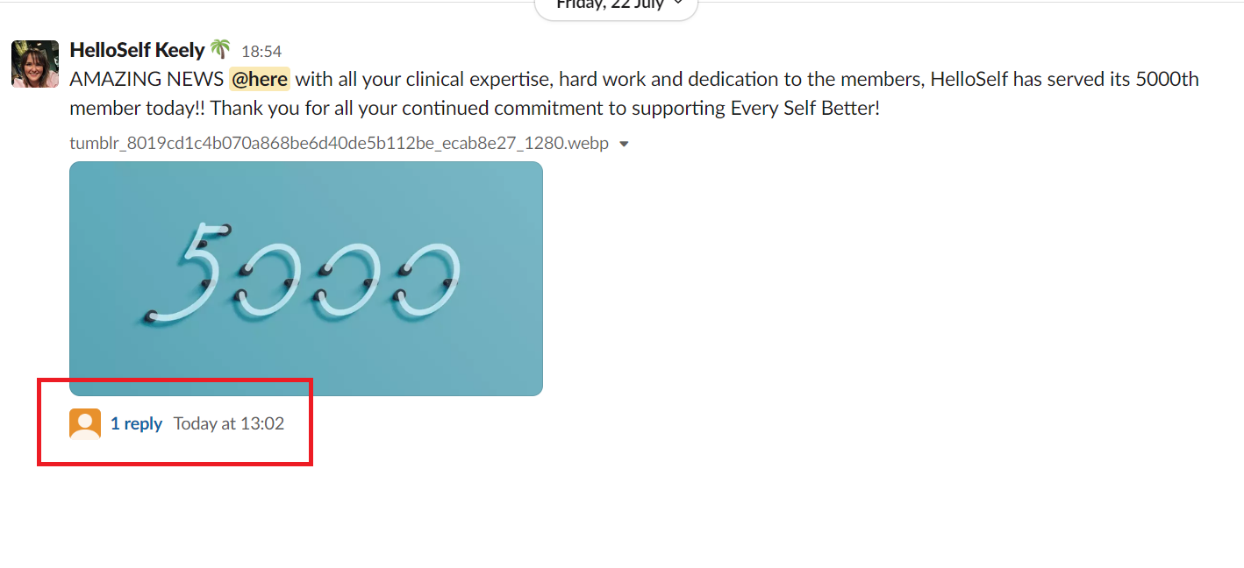
- Another top tip is the use of the @ symbol which put before a name will notify the person who you are tagging.
- Other channels coming soon:
  - (coming soon) CD panel channels
  - (coming soon) Specialist peer to peer channels
  - (coming soon) Associate Expert Panel: quarterly groups chosen to be our sounding board for HS developments. Be that testing new product features, giving us feedback on the platform or reviewing our marketing messaging, we need your expertise and input as we continue to grow.

